*\*This guide assumes that the project has been cloned and local changes have been made that need to be built and deployed to production.*

**Step 1) Build local changes**  
In an administrator terminal, Navigate to the root npm directory Nursing-App\clientform (where package.json is located) and perform the following command:  
  
 ***npm run build***

*Note: if the command above fails you either have not ran ‘npm  
 install’ in this directory or npm is not in your windows PATH.

This will create a ‘dist’ folder in that directory with a ‘static’ folder and ‘index.html.’

**Step 2)** **Download the Firebase CLI**

In the same directory, we need to download the Firebase CLI with node using the following command:

***npm install -g firebase-tools***

**Step 3)Strikethrough items are done. Targets can be set here:**

**~~Step 3) Create the ‘firebase.json’ file~~**

~~In this same directory, create the following files with either windows explorer or a code editor:~~ ***~~firebase.json~~*** ~~Place the following code in this file via your favorite code editor:~~

{

"hosting":{

"public":"dist",

"ignore": [

"firebase.json",

"**/.*",

"**/node_modules/**"

],

"rewrites":[

{

"source":"**",

"destination":"/index.html"

}

]

}

}

**Step 3.1)Targets:**

ONLY USE TARGETS IF YOU WANT TO CHANGE THE URL OF THE WEBSITE.   
Navigate to Firebase database page, click hosting, click add another site, add site name.   
  
As follows:

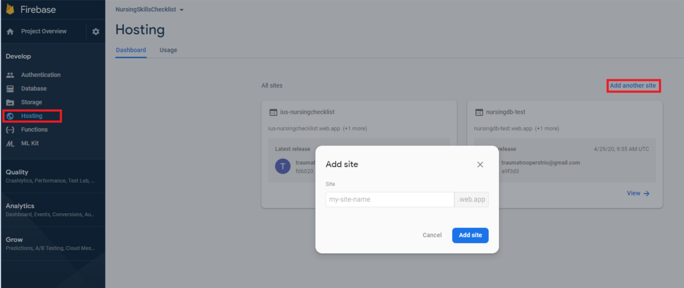

Targets are created by command line (with the firebase CLI npm module) to create an alternate URL for hosting.

This command:

firebase target:apply hosting checklist ius-nursingchecklist

Creates a hosting target called “checklist” which deploys to the url

“<https://ius-nursingchecklist.web.app/>”.

We set this in our firebase.json as follows:

**{**

**"hosting":{**

**"target":"checklist",**

**"public":"dist",**

**"ignore": [**

**"firebase.json",**

**"**/.*",**

**"**/node_modules/**"**

**],**

**"rewrites":[**

**{**

**"source":"**",**

**"destination":"/index.html"**

**}**

**]**

**}**

**}**

**Read more about targets here:**[**https://firebase.google.com/docs/cli/targets**](https://firebase.google.com/docs/cli/targets)

**Step 4) Create the ‘.firebaserc’ file**

In this same directory, create the following file:  
  
 ***.firebaserc***  
  
Place the following code in this file via your favorite code editor:

{

"projects": {

"default": "nursingdb-test"

}

}

**Proceed to step 5 if not using a new target** (setting a new URL) from step 4, the code will look like this for the example previously used:  
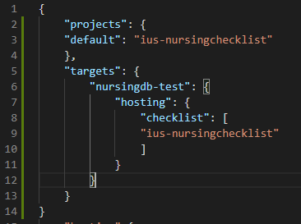

**Step 5) Confirm changes**

Confirm your folder structure has the following highlighted changes:

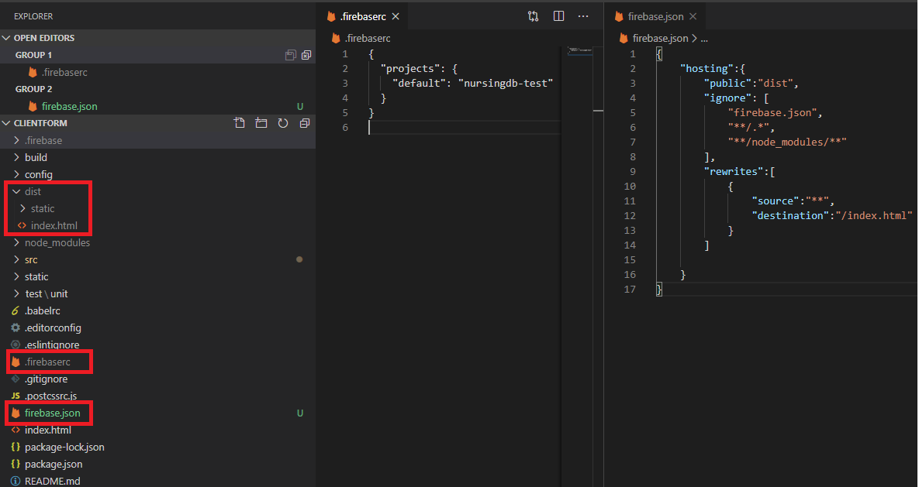

**Step 6) Login to Firebase using the CLI**

In the same directory, we can now login to Firebase using the following command:

***firebase login***

You should get a success message after running the above.

**Step 7) Deploy to Firebase**

In the same directory, we can now deploy our changes with the Firebase CLI using the following command:

***firebase deploy***

This command deploys the ‘dist’ folder that we updated above in the build section to the Firebase project we have created.

The updated project will now be available here:

[Nursingdb-test.web.app](http://nursingdb-test.web.app) or whatever target was set.  
  
Edit: since first making this document, a new target was created and the Url is set to :

<https://ius-nursingchecklist.web.app/>  
  
**Step 8) Future Deployments**

Since we have already done the hard work locally, future deployments are much easier and only require the following command:  
  
 ***npm run build && firebase deploy***

Reference: <https://medium.com/@rachidsakara/how-to-deploy-vue-js-applications-with-firebase-hosting-40cfa7f724e4>